Patterns
Write a program to create the following pattern:
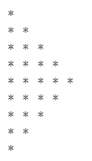
You will receive a number that represents the highest number of stars.

Example
Input | Output
3 | *  **  ***  **  *
5 | *  **  ***  ****  *****  ****  ***  **  *

